Abdurrahman Qureshi

210451

EXP17

-----------------------------------------------------------

1)**Code :**

#include<iostream.h>

#include<conio.h>

class complex

{

int num1,num2;

public:

void accept()

{

cout<<"Enter two complex numbers :\t";

cin>>num1>>num2;

}

friend complex

operator+(complex c1,complex c2);

void display()

{

cout<<num1<<"+"<<num2<<"i"<<"\n";

}

};

complex operator+(complex c1,complex c2)

{

complex c;

c.num1=c1.num1+c2.num1;

c.num2=c1.num2+c2.num2;

return(c);

}

void main()

{

clrscr();

complex c1,c2,sum;

c1.accept();

c2.accept();

sum=c1+c2;

cout<<"\nEntered values:\n";

cout<<"\t";

c1.display();

cout<<"\t";

c2.display();

cout<<"\nAddition of real and imaginary

numbers:\n";

cout<<"\t";

sum.display();

getch();

}

**Output:**

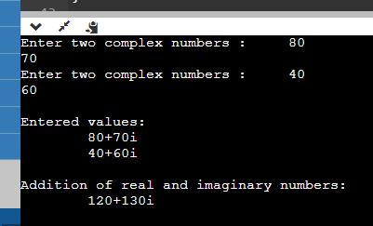

**2)Code :**

#include<iostream>

#include<conio.h>

using namespace std;

class binary {

float n;

public:

void get () {

cout << "\nEnter a number: ";

cin >> n;

}

binary operator+ (binary & a) {

binary t;

t.n = n + a.n;

return t;

}

binary operator- (binary & a) {

binary t;

t.n = n - a.n;

return t;

}

binary operator* (binary & a) {

binary t;

t.n = n * a.n;

return t;

}

binary operator/ (binary & a){

binary t;

t.n = n / a.n;

return t;

}void display () {

cout << n;

}

};

int

main (){

binary a1, a2, a3;

a1.get ();

a2.get ();

a3 = a1 + a2;

cout << "\n\nAddition of two number: ";

a3.display ();

a3 = a1 - a2;

cout << "\n\nSubtraction of Two number: ";

a3.display ();

a3 = a1 * a2;

cout << "\n\nMultiplication of two number: ";

a3.display ();

a3 = a1 / a2

cout << "\n\nDivision of two number: ";

a3.display ();

return 0;

}

**Output:**

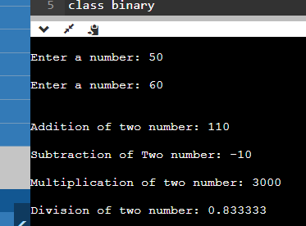

**3)Code :**

#include<iostream.h>

#include<string.h>

#include<conio.h>

class string

{

char str[20];

public:

void get()

{

cout<<"enter string:";

cin>>str;

}

void operator==(string c)

{

if(strcmp(str,c.str)==0)

{

cout<<"string are equal....\n";

}

else

{

cout<<"string are not equal....\n";

}

}

};

void main()

{

clrscr();

string s1,s2;

s1.get();

s2.get();

s1==s2;

getch();}

**Output:**

